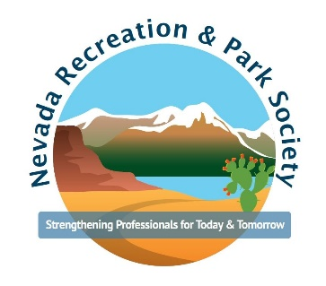
NPRS Member Monday Application

Please fill out the questionnaire below and email this application and a photo of yourself to Jordyn.Wright@cityofhenderson.com

Current Title and Place of Work:

What brought you to Parks and Recreation?

Please list any certifications, degrees, or accomplishments you would like to include:

What do you like to do outside of work (hobbies or interests)?

Any other fun facts you would like to include?

