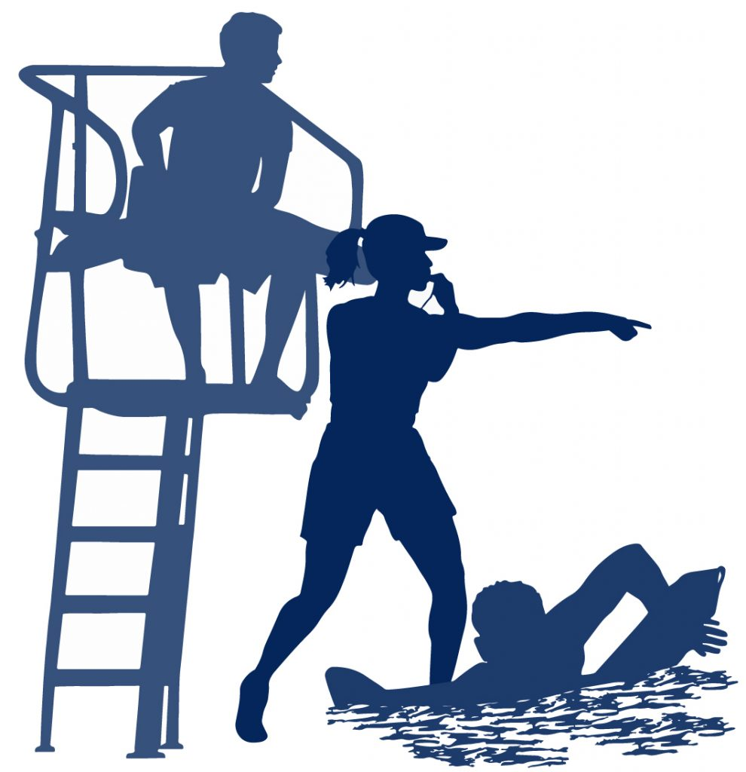

WE’RE LOOKING

FOR YOU!

**NOW HIRING MORNING LIFEGUARDS!**

**MUST HAVE CURRENT AMERICAN RED CROSS LIFEGUARD/ FIRST AID/ CPR/ AED CERTIFICATION!**

**Apply online at** [**www.bcnv.org/careers**](http://www.bcnv.org/careers)

**For more information call us at (702)-293-9286**